**AMERICAN INTERNATIONAL UNIVERSITY-BANGLADESH**

**Faculty of Science and Technology**



**Course Title: Data Communication**

**Lab Report-3**

**Exp. Title: Analog Signal quantization using MATLAB**

|  |  |
| --- | --- |
| ***Submitted by:***  **Name: Shifat, Shadril Hassan**  **ID: 20-42451-1**  **Section: G**  **Program: BSc CSE**  **Semester: Spring 2021-2022**  **Date: 28 February, 2022** | ***Submitted to:***  **Course Teacher: Tanjil Amin** |

Performance Task for Lab Report: (your ID = AB-CDEFG-H)

**x(t) = (H+5)*cos(2π((D+E+5)*10)t) + (H+7)*sin(2π((E+F+10)*10)t)  
Q:** Apply uniform quantization on signal ‘x(t)’ using both of the manual quantization methods  
learnt in this manual. Use (2H + 2) levels for first method and use (12 - 2H) levels for the second  
one. Attach codes and necessary figures in your report.

**Solution (Method- 1):**

**MATLAB Code:**

clc;

clear all;

close all;

%ID= 20-42451-1

A=2;

B=0;

C=4;

D=2;

E=4;

F=5;

G=1;

H=1;

level= 2^H + 2;

fs=50000;

t=0:1/fs:0.1;

xt= (H+5)*cos(2*pi*((D+E+5)*10)*t) + (H+7)*sin(2*pi*((E+F+10)*10)*t);

Nsamples=length(xt);%calculating the total number of samples

quantised_out= zeros(1,Nsamples);

del=(max(xt)-min(xt))/level;%determining the step size

Llow= min(xt)+del/2;

Lhigh= max(xt)-del/2;

for i=Llow:del:Lhigh

for j=1:Nsamples

if(((i-del/2)<=xt(j)) && (xt(j)<=(i+del/2)))

quantised_out(j)=i;

end

end

end

plot(t,xt,'r-.','linewidth',1.5);

hold on;

plot(t, quantised_out,'b-.','linewidth',1.5);

xlabel('time');

ylabel('amplitude');

title('manual quantization of signal x(t) (method-1)');

legend('Original signal','Quantized signal');

**Output:**

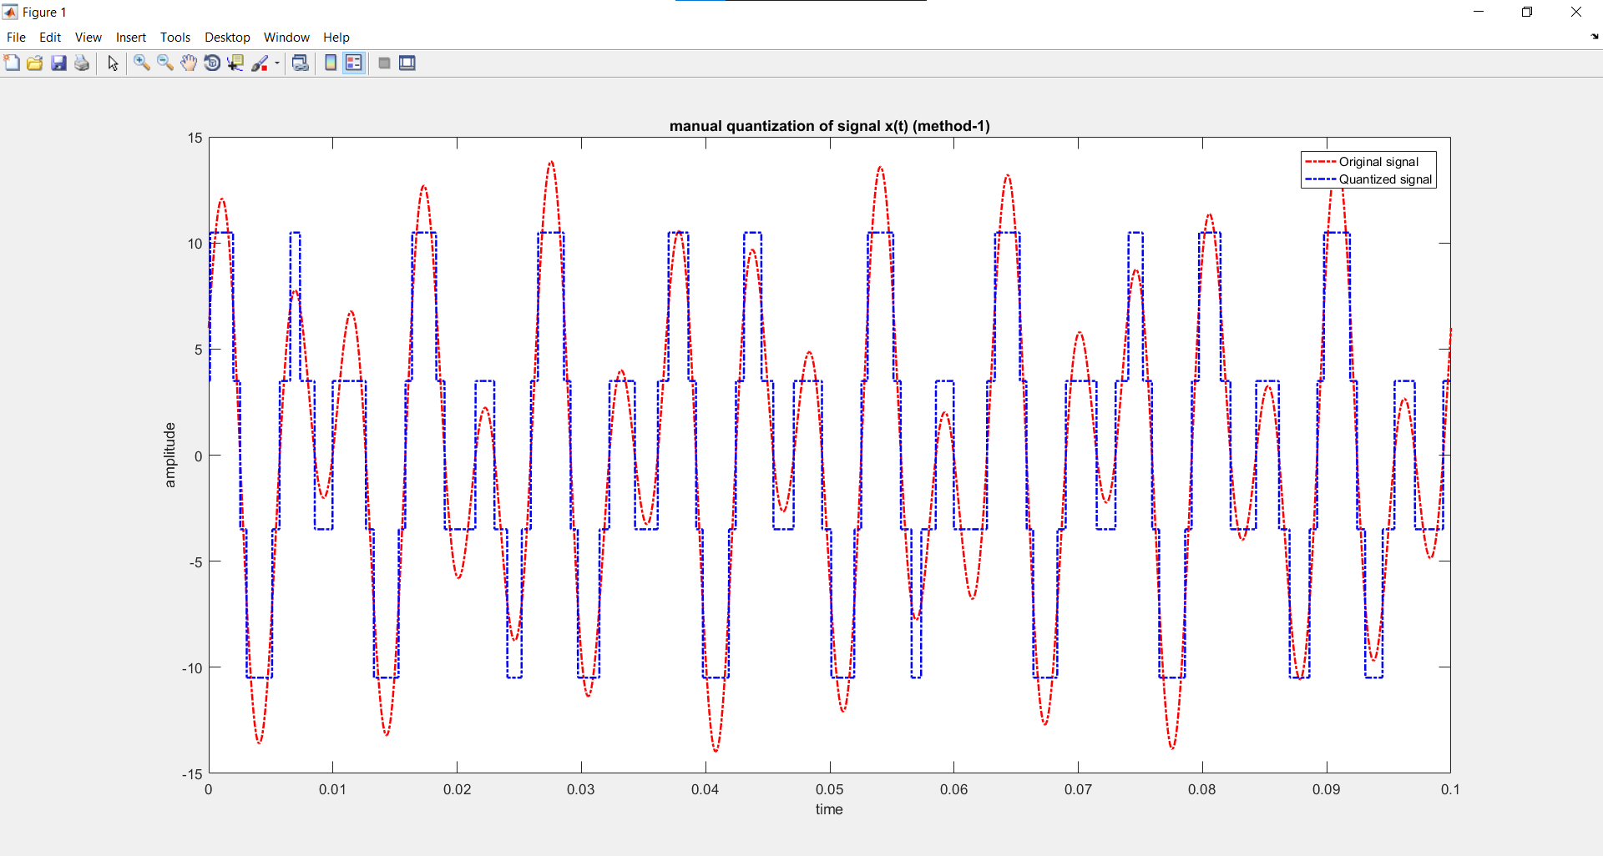

**Solution (Method- 2):**

**MATLAB Code:**

clc;

clear all;

close all;

%ID= 20-42451-1

A=2;

B=0;

C=4;

D=2;

E=4;

F=5;

G=1;

H=1;

fs= 50000;

t=0:1/fs:0.1;

xt= (H+5)*cos(2*pi*((D+E+5)*10)*t) + (H+7)*sin(2*pi*((E+F+10)*10)*t);

%quantization

level=12-2^H;

delta= (max(xt)-min(xt))/(level-1);

xq=min(xt)+(round((xt-min(xt))/delta)).*delta;

%plotting

plot(t,xt,'r-.', 'linewidth',1.5);

hold on;

plot(t,xq,'b-.', 'linewidth',1.5);

xlabel('time');

ylabel('amplitude');

title('manual quantization of signal x(t) (method-2)');

legend('original signal','quantized signal');

**Output:**

